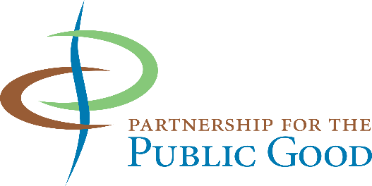

For Immediate Release Sam Magavern, 852-4196
January 13, 2017 sam@ppgbuffalo.org

Community Groups Unveil their Policy Agenda for 2017

“This is democracy in action,” said Partnership for the Public Good co-director Lou Jean Fleron, as the group unveiled its 2017 Community Agenda in a festive event at the Merriweather Library.

“Over 250 community groups, ranging from block clubs to social service agencies, from theaters to environmental advocates, have come together to identify the top policy actions that state and local governments can take in the coming year to build a better Buffalo Niagara,” Fleron explained.

Each fall PPG leads a democratic process among its partners to determine the Community Agenda for the coming year. This year’s Agenda addresses topics such as lead poisoning, improving public transit, development on the outer harbor, language access, child care subsidies and climate change. In the eight years of forming a Community Agenda, PPG partners have seen many of their goals become realities, on issues such as green affordable housing, economic development policy, arts funding, paid family leave and raising the minimum wage.

“Given today’s policy landscape, it’s more critical than ever that we engage in the local and state arenas,” said Megan Connelly, PPG director of policy advancement. “Our Community Agenda is a truly collaborative process moving towards both short and long-term solutions to improve the lives of all community members. Creating a more equitable Buffalo requires a community-driven plan resulting in collective action.”

The Community Agenda was announced to the community at an event that opened with the powerful spoken word of Aitina Fareed Cooke and closed out by members of Pure Ink Poetry. Speakers included Sheri Scavone from the Western New York Women’s Foundation, Steven Sanyu from Burmese Community Services, Cara Matteliano from the Community Foundation for Greater Buffalo, Annette Lott from Fruit Belt United, John Washington from PUSH Buffalo, Kirk Laubenstein from the Coalition for Economic Justice and more.

PPG and its partners will be visiting with elected leaders in the coming months to review the Agenda with them and ask for their support. The eleven planks are titled:

- Make the NFTA work for Buffalo Niagara
- Increase Accommodation and Access Policies for Immigrants and Refugees in Western New York
- Support a Fruit Belt Community Land Trust
- Ensure Lead-Safe and Healthy Homes
- Create a More Independent Commission on Citizen Rights and Community Relations for City of Buffalo
- Reduce Poverty by Supporting Transitions off of Public Assistance
- Make the New York State Office of Persons with Developmental Disabilities Accessible for All
- Preserve and Expand Child Care Subsidies for Working Families
- Create a Signature Park on the Outer Harbor
- Make Community Benefits Agreements to ensure that Buffalo’s Banks Invest in and Support Communities of Color and Low-Income Communities
- Pass the Climate and Community Protection Act

The full text of each plank is available at PPG’s web site, www.ppgbuffalo.org.

